SIGNALWELL AI

UNIQUE ID: E0324097, E0324098
NAME: ASHWIN A, NIKILESH J R
RESULTS:
SLEEP ANALYSIS:
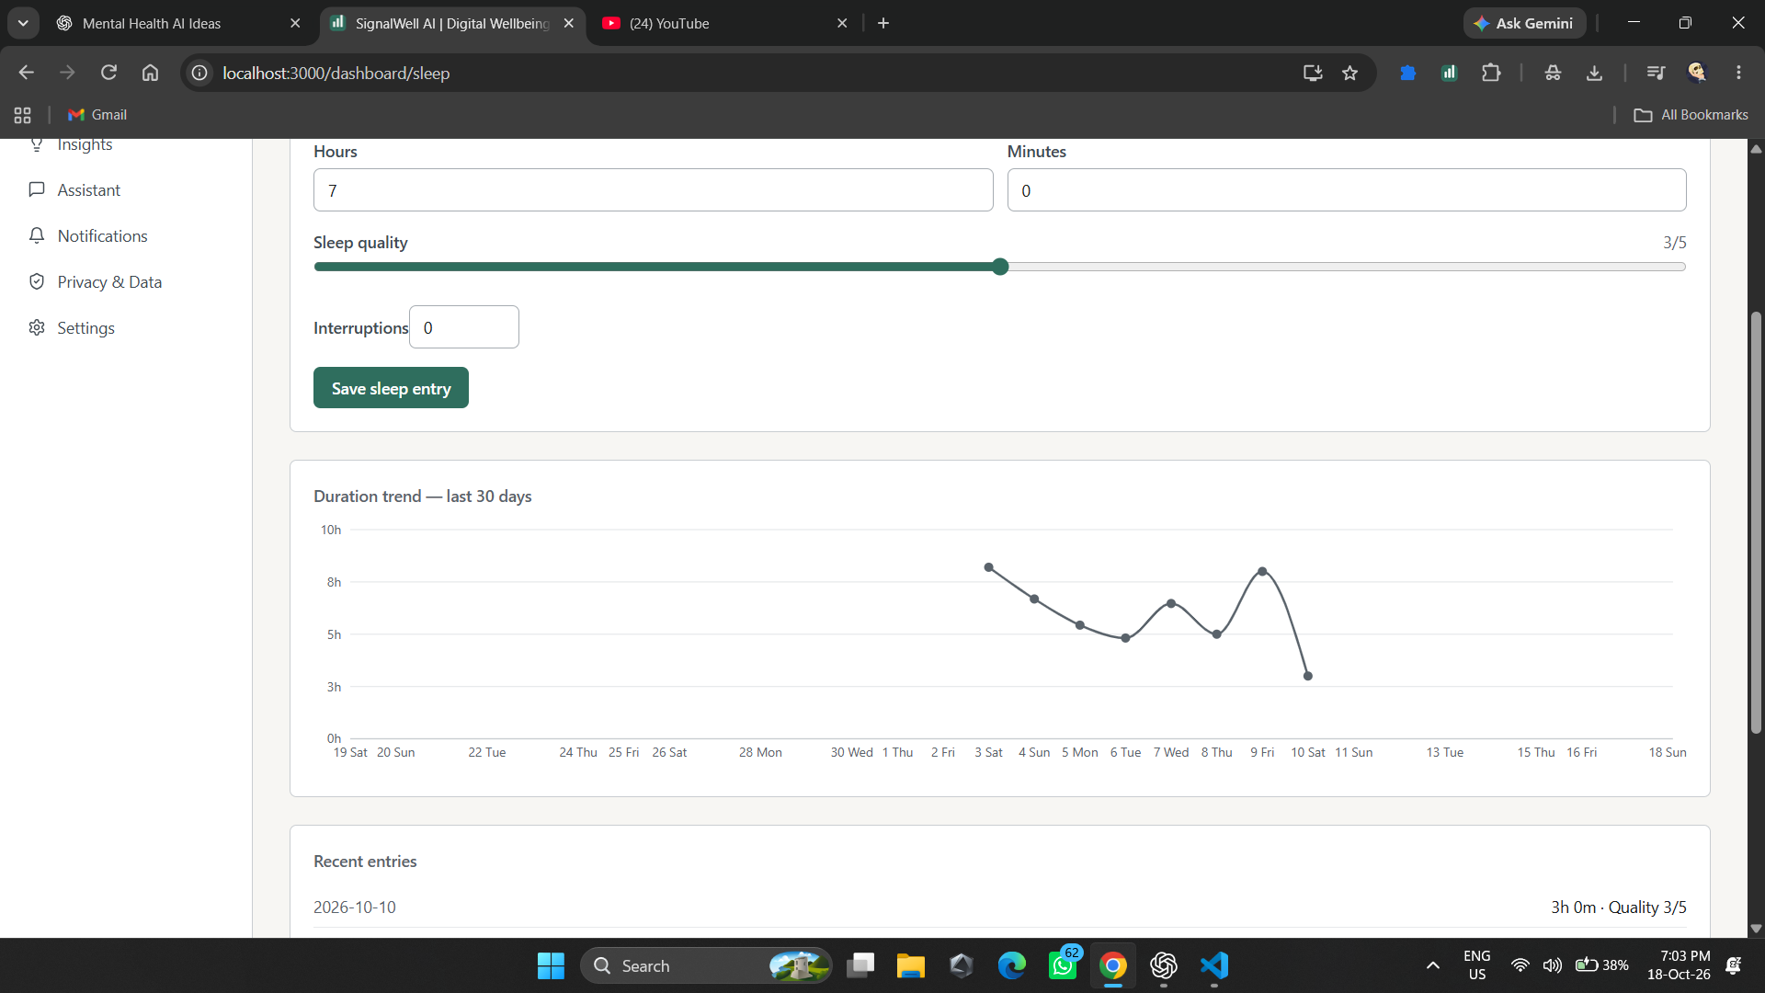
MOOD ANALYSIS:
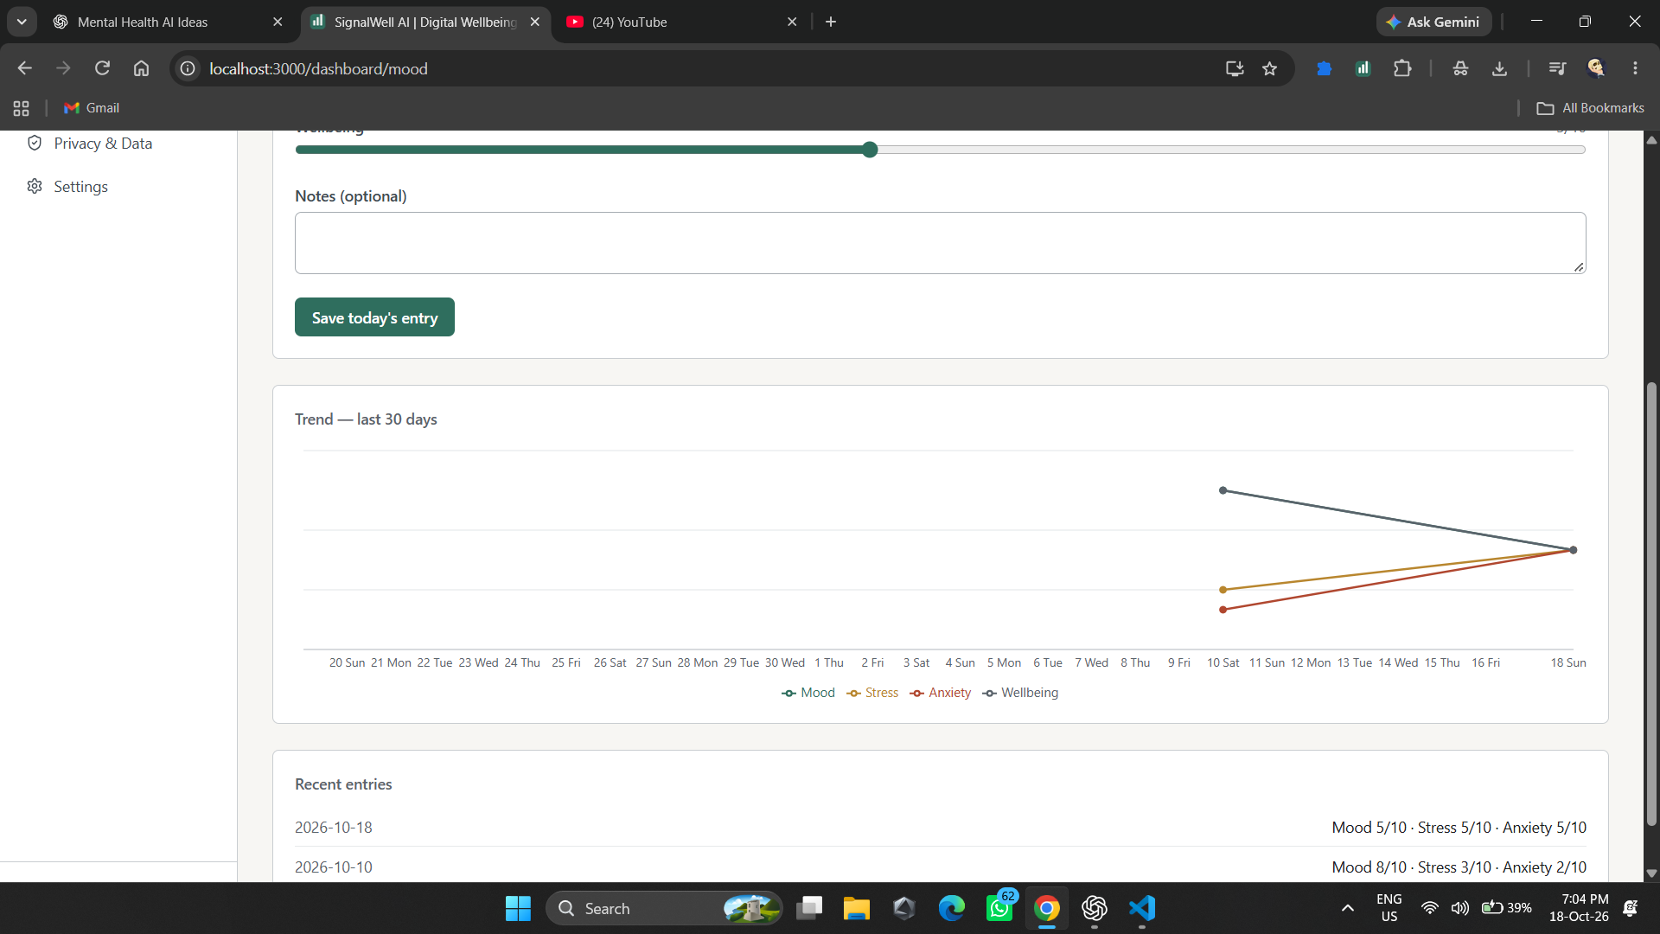

ACTIVITY ANALYSIS:
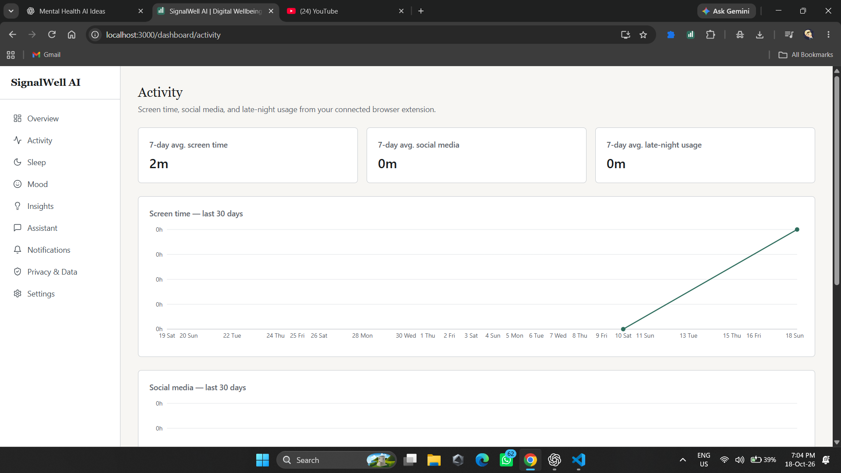

EXTENSION:


